WEEK 2, Step 1, Sub-step A outcome

 | km.out.cluster
1 | 12
2 | 49
3 | 49
4 | 49
5 | 49
6 | 49
7 | 49
8 | 49
9 | 49
10 | 29

WEEK 2, Step 1, Sub-step B outcome
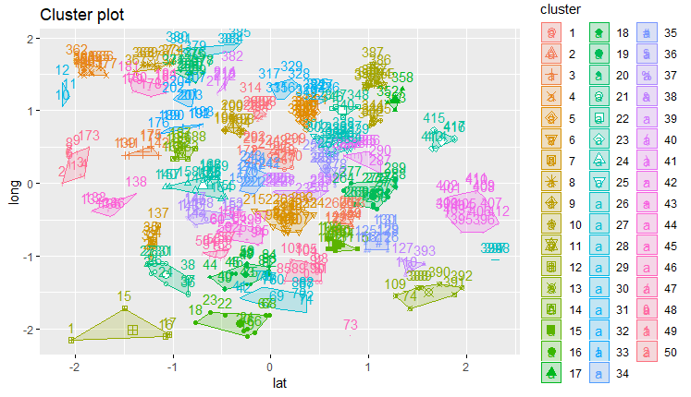
WEEK 2, Step 1, Sub-step C outcome
 | geohash | obs | tmin | tmax | days | lat | long | lat_err | lon_err | km.out.cluster
1 | sx8d2x0w6m9 | 2125 | 2018-02-10 11:00:00 | 2018-05-29 19:00:00 | 108.291666666667 | 42.62256 | 23.22588 | 6.705523e-07 | 6.705523e-07 | 12
2 | sx8d6wdpqpv | 3288 | 2018-03-26 15:00:00 | 2018-08-16 15:00:00 | 143 | 42.62000 | 23.31600 | 6.705523e-07 | 6.705523e-07 | 49
3 | sx8d6xtudev | 4439 | 2017-09-06 23:00:00 | 2018-03-26 11:00:00 | 200.5 | 42.62500 | 23.32100 | 6.705523e-07 | 6.705523e-07 | 49
4 | sx8d6xv47qk | 3214 | 2018-03-26 18:00:00 | 2018-08-16 15:00:00 | 142.875 | 42.62600 | 23.32000 | 6.705523e-07 | 6.705523e-07 | 49
5 | sx8d6z17phw | 3247 | 2018-03-26 15:00:00 | 2018-08-16 15:00:00 | 143 | 42.62200 | 23.32600 | 6.705523e-07 | 6.705523e-07 | 49
6 | sx8d6z45nkx | 3963 | 2017-10-09 02:00:00 | 2018-03-26 15:00:00 | 168.541666666667 | 42.62200 | 23.32700 | 6.705523e-07 | 6.705523e-07 | 49
7 | sx8d6z4gju9 | 3306 | 2018-03-26 15:00:00 | 2018-08-16 15:00:00 | 143 | 42.62200 | 23.32800 | 6.705523e-07 | 6.705523e-07 | 4

WEEK 2, Step 1, Sub-step D outcome
Tyk triabva da se kopira chast ot dataframe “rdist”
WEEK 2, Step 1, Sub-step E outcome
Tyk triabva da se kopira chast ot vectora “mindist”
WEEK 2, Step 1, Sub-step F outcome
Tyk triabva da se kopira chast ot dataframe “df2”

