import numpy
from pandas import Series
from matplotlib import pyplot
import matplotlib.pyplot as plt
from pandas.tools.plotting import autocorrelation_plot
from statsmodels.graphics.tsaplots import plot_pacf
from statsmodels.graphics.tsaplots import plot_acf
from pandas import DataFrame
from statsmodels.tsa.arima_model import ARIMA
import statsmodels.api as sm

series = Series.from_csv('price_data_3.csv', header=0)
split_point = len(series)
dataset, validation = series[0:split_point], series[split_point:]
print('Dataset %d, Validation %d' % (len(dataset), len(validation)))
dataset.to_csv('dataset.csv')
validation.to_csv('validation.csv')

print(series)
X=series.values
# Plot Data
pyplot.plot(X)
pyplot.show()
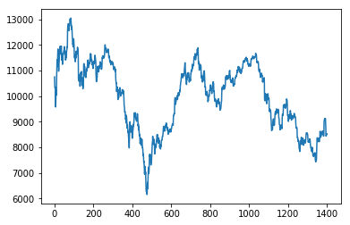

#
# plot PACF Partial Autocorrelation for ORIGINAL Data
print('PACF ORIGINAL Data')
pyplot.figure()
plot_pacf(series, lags=60)
pyplot.show()
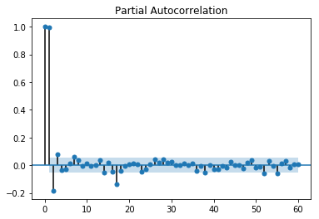
#Differenced Data
diff = list()
for i in range(1, len(X)):
value = X[i] - X[i - 1]
diff.append(value)

# Plot Differenced Data
pyplot.plot(diff)
pyplot.show()
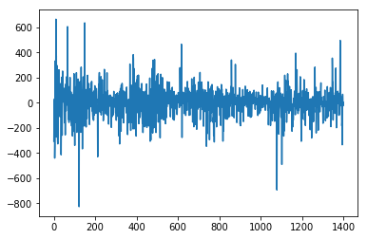

print('ACF Differenced Data ')
plot_acf(diff)
pyplot.show()

print('PACF Differenced Data')
pyplot.figure()
plot_pacf(diff, lags=60)
pyplot.show()
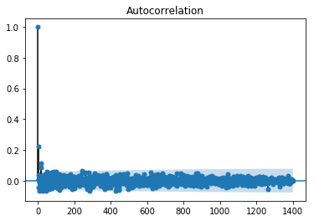
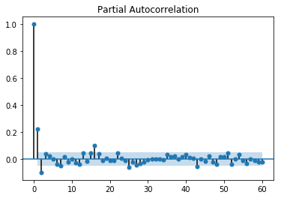

series = Series.from_csv('price_data_3.csv', header=0)
print(series)
X=series.values
X=numpy.array(X).astype('float')
order=(3,1,1) # (1,1,1)
#
print 'START ARIMA',order,' for price_data_3 Example '
model = ARIMA(X, order)
model_fit = model.fit(disp=0)
print(model_fit.summary())
# plot residual errors
residuals = DataFrame(model_fit.resid)
print('Plot Residuals')
residuals.plot()
pyplot.show()
residuals.plot(kind='kde')
pyplot.show()
print(residuals.describe())
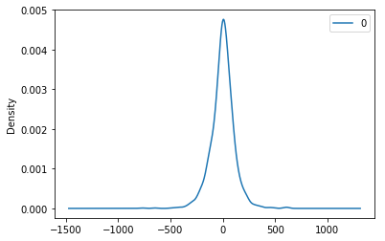

print 'Autocorrelation plot for Residuals and ARIMA',order,' for price_data_3 Example '
plot_acf(residuals)
pyplot.show()
#
print 'Partial Autocorrelation plot for Residuals and ARIMA',order,' for price_data_3 Example'
plot_pacf(residuals)
pyplot.show()
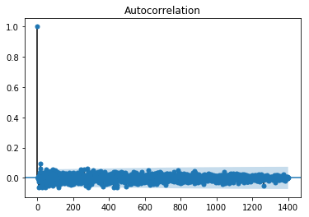
DWT = sm.stats.durbin_watson(residuals)
print 'Durbin-Watson Test=',DWT
#

r,q,p = sm.tsa.acf(residuals, qstat=True)
data = numpy.c_[range(1,41), r[1:], q, p]
table = DataFrame(data, columns=['lag', "AC", "Q", "Prob(>Q)"])
print table.set_index('lag')

print
size = int(1350)
train = X[0:size] # множество за …..
test = X[size:len(X)] # множество за тестване
history = [x for x in train]
predictions = list()

for t in range(len(test)):
model = ARIMA(history, order)
model_fit = model.fit(disp=0)
output = model_fit.forecast()
yhat = output[0]
predictions.append(yhat)

obs = test[t]
history.append(obs)

print('=%i, predicted=%f, expected(real)=%f' % (size+t,yhat, obs))
“Results :”
=1350, predicted=8185.414492, expected(real)=8208.167000
=1351, predicted=8204.412456, expected(real)=8372.262000
=1352, predicted=8423.435396, expected(real)=8233.721000
=1353, predicted=8184.571883, expected(real)=8237.831000
=1354, predicted=8262.054539, expected(real)=8232.435000
……………………….
=1397, predicted=8366.265289, expected(real)=8436.937000
=1398, predicted=8462.984500, expected(real)=8503.049500
=1399, predicted=8503.507202, expected(real)=8532.541000
=1400, predicted=8527.602368, expected(real)=8506.588000
=1401, predicted=8497.237501, expected(real)=8507.403333

def difference(dataset, interval=1):
diff = list()
for i in range(interval, len(dataset)):
value = dataset[i] – dataset[i – interval]
diff.append(value)
return numpy.array(diff)

def inverse_difference(history, yhat, interval=1):
return yhat + history[-interval]

# load dataset
series = Series.from_csv('dataset.csv', header=None)
# seasonal difference
X = series.values
days_in_year = 365
differenced = difference(X, days_in_year)
# fit model
model = ARIMA(differenced, order=(3,1,1))
model_fit = model.fit(disp=0)
# one-step out-of sample forecast
forecast = model_fit.forecast()[0]
# invert the differenced forecast to something usable
forecast = inverse_difference(X, forecast, days_in_year)
print('Forecast: %f' % forecast)

print
print 'Durbin-Watson Test=',DWT
print('ARIMA ',order)
MFE = (predictions-test).mean()
print "MFE = ",MFE
import numpy
MAE = (numpy.abs((predictions-test).mean()) / predictions).mean()
print "MAE = ", MAE
#
from sklearn.metrics import mean_squared_error
rmse = numpy.sqrt(mean_squared_error(test, predictions))
print('Test RMSE: %.3f' % rmse)

# plot
pyplot.plot(test)
pyplot.plot(predictions, color='red')
pyplot.show()

